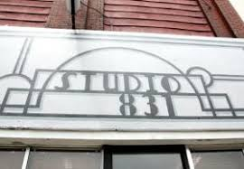
Poetry at Studio 831!
Featuring material from the newly-released Cleave
by Kansas City poet Boyd Bauman
Thursday, July 21 from 6:30 - 8 p.m.

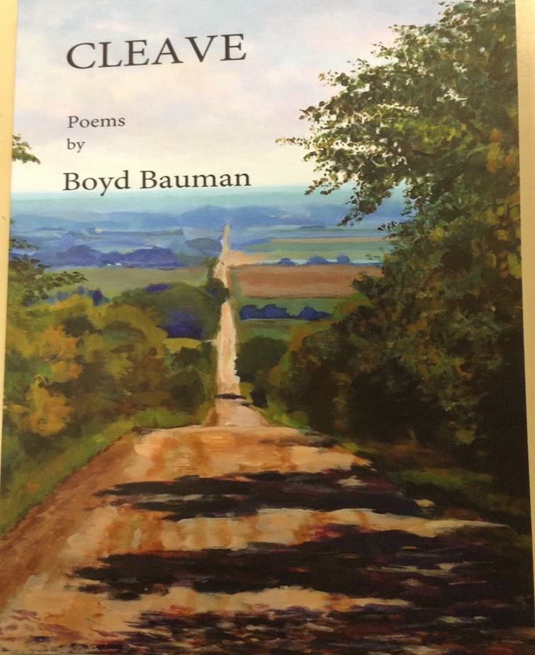
“From Sisyphus to Kierkegaard, from Keats to Kerouac, Bauman’s poems take us on a philosophical and literary journey, one which involves a serious social commentary, braced by a wry smile and a salty tear. These poems are best read in a railroad yard, book in hand with an eye trained on the sturdiest of wild flowers.”
- Al Ortolani

