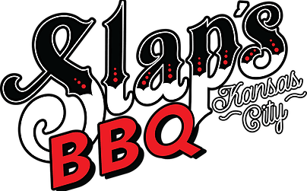

BARDS, BREWS, AND BBQ

KC writer Boyd Bauman reads from his new poetry book
Scheherazade Plays the Chestnut Tree Cafe
Wednesday, May 8, from 6 p.m. – 7 p.m.
Slap’s BBQ covered patio
553 Central, KCK
(Additional parking at Splitlog Coffee)

